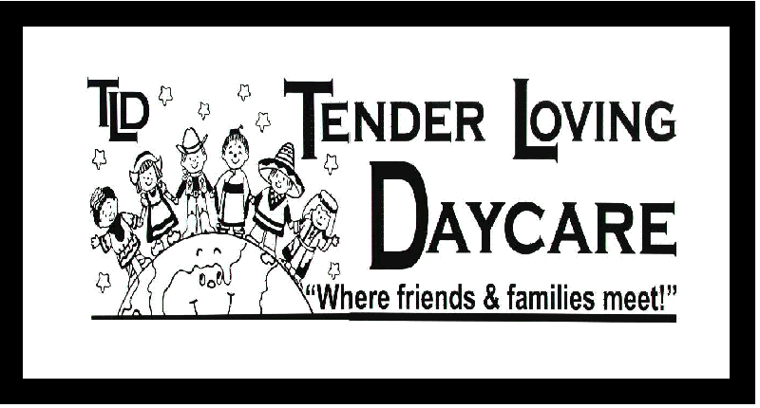
Subsidy Contract

Child's Name: ___________________________

Subsidy Coverage starting date: ______________________ Rate of Coverage: _______________
Subsidy Coverage termination date: ______________________ Subsidy Contact: ________________

Hours of Care Required:
- I require care to be provided on the following days:
 Monday  Tuesday  Wednesday   Thursday  Friday  Variable
- I require care to be provided for the following hours:
 Full-time (maximum 9 hours)  Part-time (6:30 – 11:30, 6:30 – 12:30, 11:30 – 6:00, 12:30 – 6:00)
 Variable: __________________________________________________
Days and Hours of care covered by Subsidy are:
 All Required Days  Variable Days (please specify): _____________________
Method of Payment
 Fully subsidized  Partially subsidized parent contribution is: ______________________

I have entered into a contact with the Region of Waterloo for childcare subsidy for my child and agree to abide by all the policies and procedures set out in this agreement. The Region of Waterloo will be covering all regular program fees* for my child until my termination date. I understand that if care is provided during a time in which I am not covered by subsidy, or in which I have a partial subsidy contract with a partial payment to the centre, that I will be held financially responsible for all fees incurred during that period. As well as the policies and procedures of regular fee paying parents as per the TLD Parent Handbook. If at any time subsidy provides retroactive coverage of my fees, once conformation is received from the subsidy office, all fees paid by me will be reimbursed back to date coverage resumed. I understand that failure to provide accurate and timely information may result in termination of my subsidy contract with Tender Loving Daycare.

- Please note that regular program fees cover the basic weekly fee and do not include any late charges incurred by a parent.

________________________ _______________________ ______________

Parent/Guardian Tender Loving Daycare Date
Signature Signature

