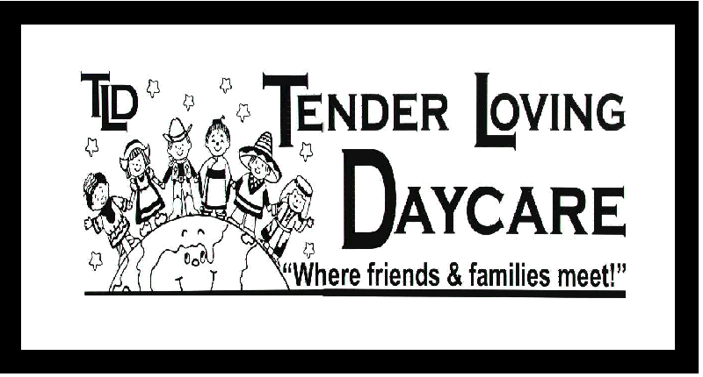
Parental Consent Form
Child’s Full Name: ___________________________ Date of Birth: ______________

Sunscreen Application Consent

I authorize the application of additional sunscreen to my child by Tender Loving Daycare. Staff will apply lotion. This will be done 30 minutes prior to going outdoors and as required after water play or extreme physical activity. If you arrive while we are outside/transition to outdoors, you will be asked to apply the sunscreen. Please ensure that sunscreen is here daily as we cannot apply sunscreen that has not been provided by the parent.
 Yes I agree  No thank you, my child will not require sunscreen

First Aid Consent
When access to warm running water and soap is available all minor first aid needs shall be treated with running water and soap. All accidents requiring minor first aid will be reported in writing reviewed and signed by parents upon arrival in the evening and kept on file at the center and a copy given to the pick- up person. In the event that a child requires more then minor first aid the parent will be called immediately to discuss action to be taken. I authorize the application of first aid to my child by the staff at Tender Loving Daycare.
 Yes I agree  No thank you

Local Walks & Outings
From time to time the program may plan spontaneous walks to near by local attractions. Outings will only be taken once good group control has been established. Newly enrolled toddler / preschool children will always hold the hand of the teacher until they have had an opportunity to learn the safety rules. All children will hold onto a safety rope through the entire walk or will ride sitting down in a wagon. Prior notice will be given for any large field trips involving bus or public transportation and will require further written consent for each individual trip.
 Yes my child may attend.  No, my child may not attend.

Pictures & Promotional Endeavors
I authorize Tender Loving Daycare to use my child's photograph or moving image in any promotional endeavors that the center may pursue. (I.e. Newspapers, Displays at Fairs or Events, Television reports, etc.)
 Yes I agree  No my child's image may not be used

Pictures in the Classroom
I authorize Tender Loving Daycare to use photographs of my child within the learning environment.
 Yes I agree  No my child's image may not be used

___________________________ __________________________ _ _______________
Parent/Guardian Tender Loving Daycare Date
Signature Supervisor Signature

