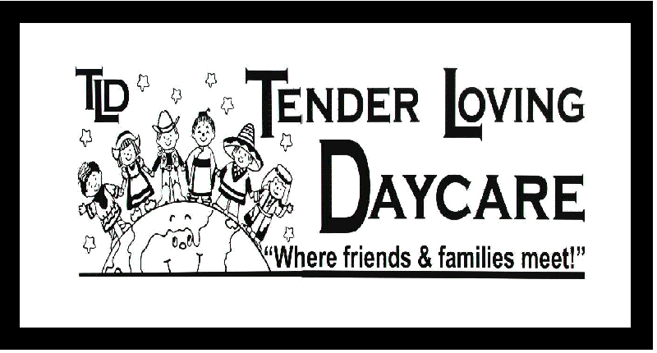
Medical Information
According to the Department of Health, Bill 142 makes it mandatory that all school children up to 18 years of age be immunized against Diphtheria, Poliomyelitis, Tetanus, Measles, and Rubella (German Measles). Please complete this form and the attached Ministry of Health immunization form and attach a copy of your current yellow immunization record signed by a physician. Under Bill 142, the Medical Officer of Health may order the suspension of a student for whom no official proof of immunization or official statement of exemption has been received.

Child’s Surname: _______________________ Child’s Given Name: _____________________
Birth Date: ___________________________  Male  Female

Does this child have:
Vision Difficulties _______________________________________________________________________
Hearing Difficulties ______________________________________________________________________
Skin Conditions / Birthmarks _______________________________________________________________
Does the Child Have Any Health Problems?  No  Yes
If Yes, Describe ________________________________________________________________________
______________________________________________________________________________________
Describe Any Allergies ( including anaphylaxis reactions) __________________________________________
______________________________________________________________________________________
Is Special Attention Required (diet, rest, physical activity, etc.) ______________________________________________________________________________________
______________________________________________________________________________________
______________________________________________________________________________________
Is this Child under Treatment for Illness or Injury?  No  Yes
If Yes, Describe ________________________________________________________________________
______________________________________________________________________________________
Will this problem interfere with their participation in activities at school?  No  Yes
If Yes, Describe ________________________________________________________________________
______________________________________________________________________________________
Communicable Diseases Child’s had: (Please Check)
Chicken Pox  No  Yes Measles  No  Yes
Scarlet Fever  No  Yes Pink Eye  No  Yes
Whooping Cough  No  Yes Rubella  No  Yes
Other (specify) _______________________________________

Any overnight Hospitalizations, Surgeries, Etc.? _________________________________________________
______________________________________________________________________________________

I agree that, to the best of my ability, the above information is an accurate account of my child's current medical background, health needs and individual requirements. My child receives regular immunization and a current record of immunization is attached as proof of immunization in lieu of a Doctors certificate of Health.

___________________________ _______________
Parent/Guardian Signature Date

