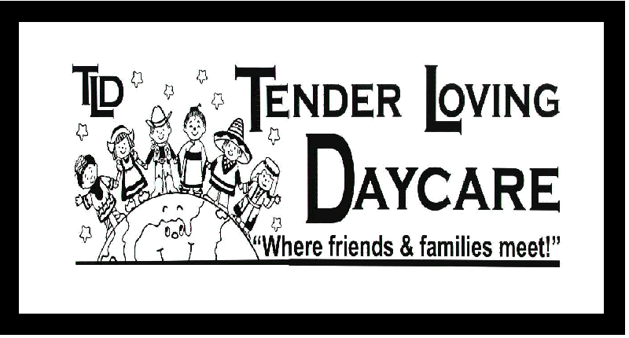
Family Special Needs Form

At Tender Loving Daycare, we attempt to accommodate the needs of the whole family in our program. Please complete the following form to help us accommodate your needs. Your needs will be shared with all staff, students and volunteers, so we can better serve you.

Do you, or anyone else in the family, have a special communication need that we should be aware of during your stay with us? (I.e. hearing, seeing, reading, writing)
______________________________________________________________________________________________________________________________________________

How can we best accommodate the above need?
_____________________________________________________________________________________________________________________________________________________________________________________________________________________

Does your child have a developmental, social or emotional needs or concerns that we should be aware? __Yes __No

Are you engaged currently with an organization that is assessing or helping with a developmental, social or emotional needs or concerns? Please name all agencies: ______________________________________________________________________________________________________________________________________________

Do you have a report or Individual Education Plan that you would like to share with the staff at TLD? ___ Yes ____ No ___ Copy provided

Are you willing to sign a release of information form so we may communicate with the above organizations to create a plan, along with yourselves, that will help your child be successful during their stay at TLD? __ Yes _____ No

Do you have specific goals as a priority for your child during their stay at TLD?
_____________________________________________________________________________________________________________________________________________________________________________________________________________________
___________________________ _______________
Parent/Guardian Signature Date

