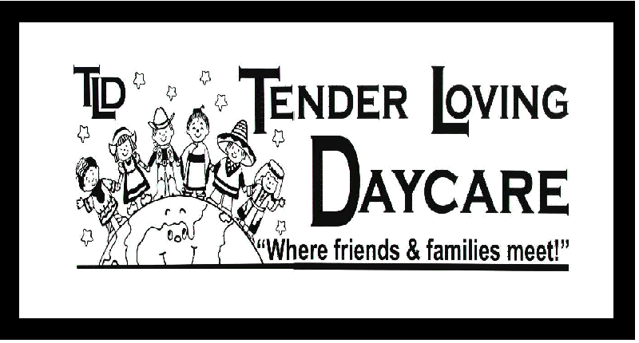
Dietary
Instructions

This is to inform Tender Loving Daycare that the following child:

Child’s Full Name: | Classroom:

- Will be sent with a nutritious breakfast due to arriving at 6:30 a.m. I acknowledge this will be served only until 7:00 a.m. and than discarded. The centre provides a morning snack if/when I arrive after 7:00 a.m.

Will be sent with food from home to supplement the daycare menu due to medical/religious restrictions. Meals/Snacks provided must meet the Canada Food Guidelines for nutrition and will be offered at regular school times.
- Has the following food allergies or dietary restrictions:

Allergy / Restriction: | Reaction if Exposed: | Precaution to be Taken:
It is the parent responsibility to keep the center up to date with changes to the food allergies or dietary restrictions. Please direct these to the office to be updated in your child’s file.

Tender Loving Daycare agrees to accommodate food allergies and restrictions by removal of the ingredient if possible or substitution of the entire meal if necessary. All staff will be made aware of my child's dietary needs and allergies/restrictions will be posted in all food preparation and serving areas and a copy placed on the classroom clipboard. The above restrictions and precautions will be taken into account when preparing all meals and snacks.

I acknowledge that if my child has a milk allergy it is my responsibility to provide an alternative source of calcium. Alternative sources will be sent in a container labeled with my child's full name and the expiry date of the replacement item. Container will be re-stocked as required.

I am aware that the centre is a “Nut Safe Zone” and will ensure that any items sent from home will have the label checked to ensure that they are free from nuts or nut bi-products. I have been informed that some doughnuts, cookies, cereal and cereal bars are made in the same manufacturing plant as products that contain nuts and will watch for labels that say “may contain nuts” and avoid sending these items as well. Any food item or container sent from home will be labeled with my child’s full name and date of preparation. I acknowledge that the TLD staff cannot serve any food or beverage item that is not properly labeled by the parent.

______________________ _____________________ ________________________ Parent/Guardian Signature Tender Loving Daycare Signature Date

